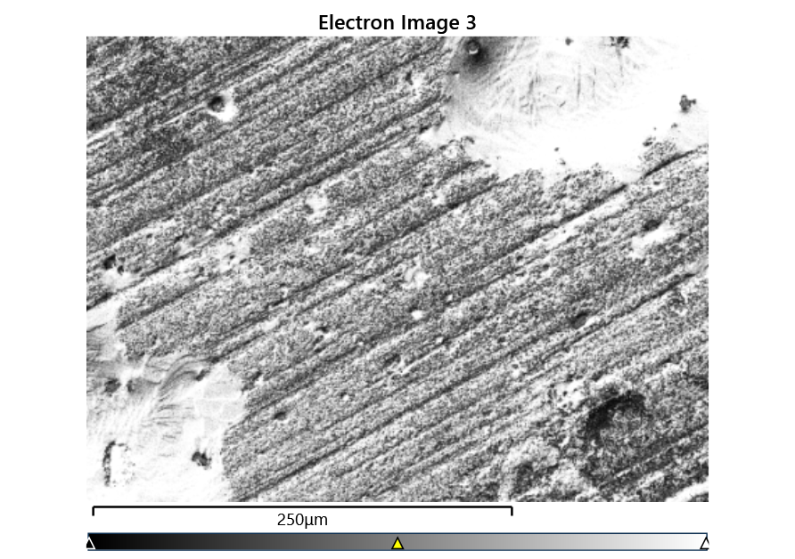



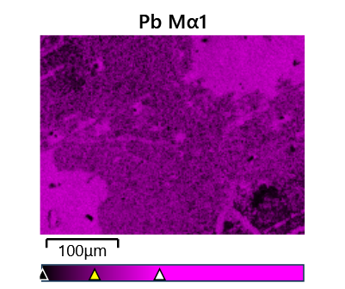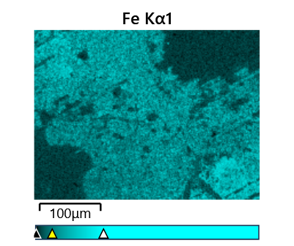

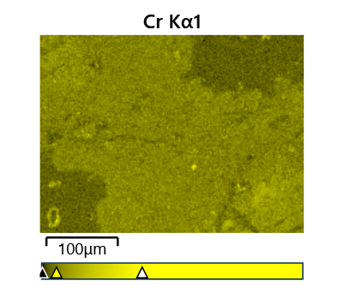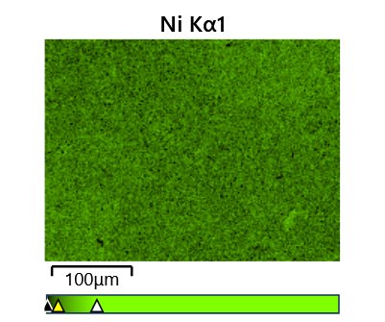

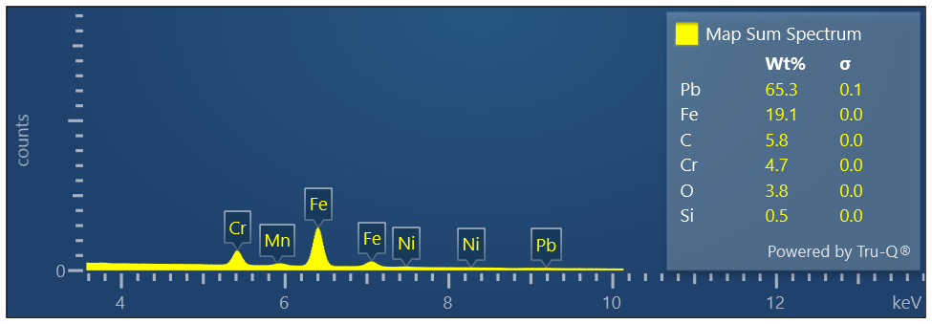

Map Sum Spectrum

Element Signal Weight % σ

Pb 73.15 0.05

Fe 21.18 0.04

Cr 5.29 0.02

Ni 0.39 0.03

**Map Sum Spectrum**

**Element Signal Atomic % σ**

**Fe 45.11**

**Pb 42.00**

**Cr 12.10**

**Ni 0.79**